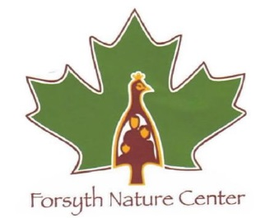
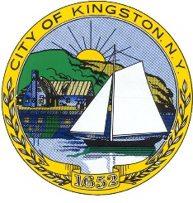
City of Kingston Parks and Recreation Junior Naturalist Program
2018 Scholarship Application Form
Sponsored by the Friends of Forsyth Nature Center
The Friends of Forsyth Nature Center seeks support from funders and community members so that we can offer scholarships to families that otherwise would not be able to send their child to camp. Scholarships are awarded based on need and the availability of funds and are only available to Kingston residents. The scholarship includes the cost of one (1) two- week camp session (except for the Session D scholarships, which are for one (1) week only). The Friends of Forsyth Nature Center will begin to review applications as received and applicants will be contacted beginning in mid-April. Funds are limited.
Scholarships are possible because of the generous donations made to the Friends of Forsyth Nature Center Scholarship Fund. The Friends of Forsyth Nature Center Scholarship Fund awards scholarships to help send as many children to attend the Junior Naturalist Program as possible. Therefore, scholarships will only be awarded for weeks or sessions that a child will be able to attend in full.
APPLICATION PROCESS:
- Complete this 2018 Scholarship Application Form.
- Return the scholarship form, registration form to: Kingston Parks and Recreation Department, 467 Broadway, Kingston, NY 12401, Attn: Julie Noble/Scholarship. Applications due by May 4, 2018.
- Scholarship recipients will be contacted by Julie Noble, Kingston Parks and Recreation, and will then complete the full Junior Naturalist Registration Form, around the second week in May. This scholarship application does not imply registration to the program is complete.
PART A: Child/Parent, Guardian Information
Applicant Name: ___________________________________________________________________
Parent/Guardian Name: _____________________________________________________________
Address: ______________________________________ State: ____ Zip Code:__________________
Home Phone Number: ___________________________ Cell phone number:___________________
Email address: _____________________________________________________________________
Age: ____ Date of Birth: _______ Gender (M/F):____School: ____________ Grade in school: _____

Please check which summer camp you are applying for (Based on grade currently enrolled in):

___Session A (K/1st grade): June 25-July 6 (no camp July 4)
___Session B (2-3rd grade): July 9-20
___Session C (4-5th grade): July 23- Aug 3
___Session D (6, 7, 8th grade): August 6-10

PART B: Qualification
Final scholarship selection is based on a variety of factors, including but not limited to, financial need. To help us with our review, please indicate if you are currently receiving any assistance from any of the programs or organizations listed below.
Please check all applicable programs below.
___ Free/Reduced School lunch program ___ Food Stamp program
___ Family Assistance/Safety Net ___ HEAP
___ Medicaid ___ SSI
___ Other, name: _________________________________________________________
If you do not qualify for any of the programs listed above, but feel that there are other circumstances affecting your either your financial stability or other reasons why you believe the applicant is particularly qualified to receive a Scholarship, please explain below.

PART C: Written Comments/Interest
The applicant, parent, guardian and/or child may submit any additional written comments or information you would like us to consider when reviewing your application, including why the child is interested in participating in the program.

Parent/Guardian’s Signature: ____________________________________ Date: __________

By accepting a scholarship, the parent and child agree to:
• Attend camp for full session in which scholarship was awarded for.
• Provide transportation for the child, to and from the program each day.
• Future scholarship applications will not be accepted unless these requirements have been completed.
Initial here: ______________

