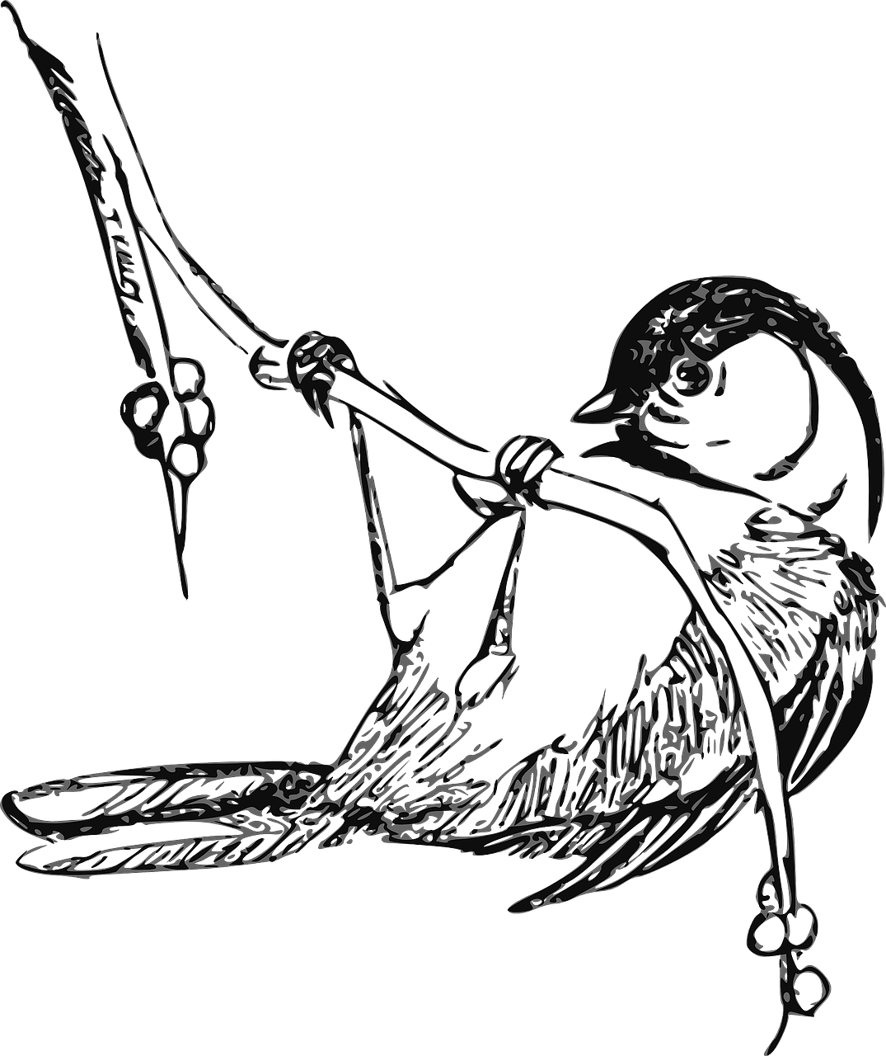
Chickadee

Native or Non-Native
Hometown or Jungle

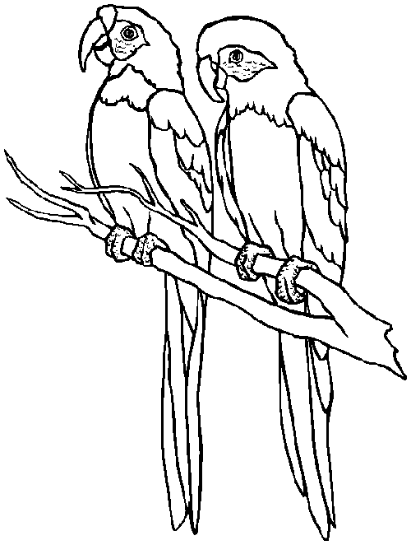
Parakeet

Native or Non-Native
Hometown or Jungle

